# SharePoint PNP tools to add responsive behaviour to SharePoint 2016 on premises installation

## Background

It’s desirable that the new Ourspace be responsive on a range of different devices including mobile. One option is Bootstrap to add responsive behaviour but apparently this involves a lot of fine tuning.

The other easier option is to use SharePoint PnP library which is more recent than Bootstrap and is a community based project led by Microsoft.

There is a guide to this process here:

<https://social.technet.microsoft.com/wiki/contents/articles/36862.sharepoint-2016-how-to-implement-responsive-ui.aspx>

The responsive files are available here:

<https://github.com/SharePoint/PnP-Tools/tree/master/Solutions/SharePoint.UI.Responsive>

## Method

To activate, I opened a Windows PowerShell ISE session and navigated to the \PnP-Tools-master\Solutions\SharePoint.UI.Responsive

Then call the Power script using:

.\Enable-SPResponsiveUI.ps1 -TargetSiteurl <http://devspace.awp.nhs.uk/sites/RWDTeam/> -InfrastructureSiteUrl http://devspace.awp.nhs.uk/sites/ReusableResources

The ReusableResources site collection provides a single location to store JavaScript and othere resources that will be reused across multiple site collections.

This worked fine but I did get the error shown below:

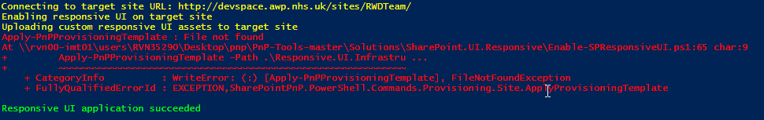

This error appears to have no effect on the functionality. As a check ensure that Style Library within the targeted site collection contains SP.Responsive.UI

The resources are uploaded to The SP.Responsive.UI folder in the Style Library as shown below.

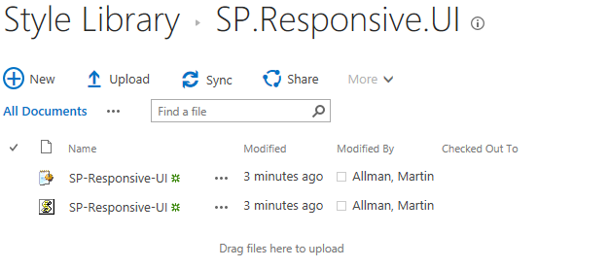

This sets responsive behaviour recursively throughout all sites created within the site collection. This worked fine in Edge //Chrome but not Internet Explorer 11.

Apparently IE11 is not able to understand map//array structures for this to work. This means that if there are any child sites the responsive behaviour breaks in IE11.

The suggested solution is to add a “polyfill” which is a series of files which plug the browser deficiency:

REF: <https://pnp.github.io/pnpjs/documentation/polyfill/>

The priority of loading needs to be set such that these are loaded before the pnp libraries.

Because of difficulties controlling the load order of these modules using the PnP Custom Action method of deployment, instead the JavaScript files have been added to customised versions of the seattle and oslo master pages: oslo-responsive-UI.html and seattle-responsive-UI.html in \\rvn00-imt01\workgroups\it systems\SP2016\Phase2\ResponsiveUI\Master Pages

We may want to add other javascript resources to these master pages e.g. JQuery.

For production it is probably best for the new master pages to be deployed to the 16 hive?

## ROLL – BACK DISABLE RESPONSIVE BEHAVOUR

Use command: Disable-PnPResponsiveUI

Again operated from \PnP-Tools-master\Solutions\SharePoint.UI.Responsive

## ISSUES

This script works fine with Seattle master template but does not work Oslo full width template. Oslo is normally used a basis for the home page so this is a bit of an issue. Might have to use Seattle for home page and hide left sidebar to overcome this issue. See : <https://github.com/SharePoint/PnP-Tools/issues/138>